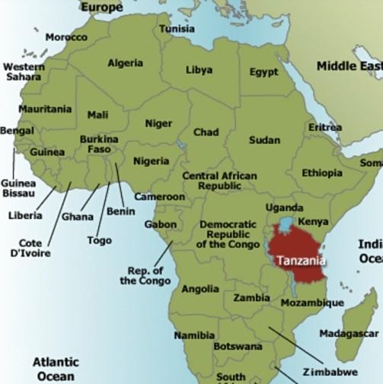Your Guide To The Kilimanjaro Trip

The XP Club is taking up to 15 individuals on a once in a lifetime adventure to the roof of Africa. Experience the adrenaline and excitement of ascending up the highest free-standing mountain in the world. Starting in rainforest and climaxing in arctic conditions at the summit, where the view will simply blow your mind. Afterwards, you may make time to take in the exotic safari expeditions or a short flight to the paradise island of Zanzibar.

Where
Kilimanjaro is situated in Tanzania, on the east coast of Africa. You will arrive at Kilimanjaro International airport via Kenya or Ethiopia and take a 45 minute journey by road to the town of Moshi, located at the feet of the mountain. Your Airport Transfers will be arranged by The XP Club.

See the section about Flights

Moshi is where you will find the Mountain Inn hotel where the rest of The XP Club will be waiting, drinks in hand and smiles on faces.

See the section about Hotels

When
You will arrive on Tuesday 12th February 2018 and spend a night at the Mountain Inn hotel in Moshi with the rest of our party.

The hike begins on Wednesday 13th February and we reach the peak in the early hours of Friday 18th February. We will be back at the hotel on Saturday
19th February where we will celebrate with a closing
party and certificate ceremony before getting some well-earned rest.
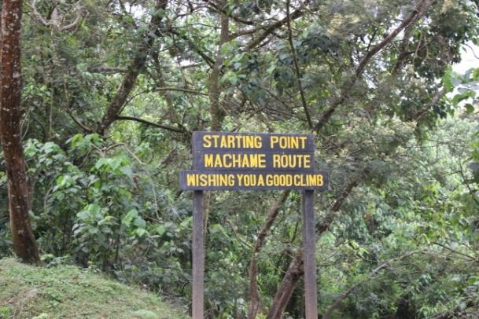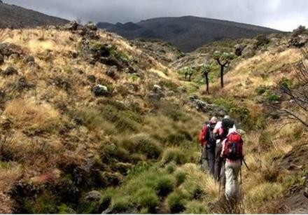

Machame Gate (1,640 meters) to Machame Camp (2,835 meters)

Zone: Rainforest

The first day trekking begins at Machame Gate (1,640 meters). We will be driven from the town of Moshi to the gate, which takes approximately an hour. On the way you will get to see farming and the town of Machame. At the Gate you will meet your trekking crew – your guide, porters and cook.

There will be a flurry of activity as porters assemble gear for the trek; weighing packs to ensure they don’t exceed 20 kilograms. You, your guide and climbing team will begin the ascent through the stunning rainforest that
covers the South-West of the mountain. The first day trek on the Machame Route takes approximately 5-7 hours to complete. The day’s trekking ends at Machame Camp (2,835 meters) which sits near the border of the rainforest zone and the low alpine zone.

By the time you arrive your porters will have already setup your camp and tents, and dinner will be served.

Day 2

Machame Camp (2,835 meters) to Shira Camp 2 (3,850 meters)

Zone: Rainforest / Low Alpine Zone

On day two you rise early with the sun, pack your gear and prepare for the trek from Machame Camp to Shira Camp 2 (3,850 meters). The trek is relatively steep as you enter the low alpine zone which is characterised by moorlands and grasslands. From here you can really start to get a perspective of the sheer vastness of the landscape; the mind begins to boggle and your imagination wanders back through time as the guide offers some ancient knowledge.

Shira Camp 2 sits on a plateau which provides you with
the first views of Kibo in the North-West and Mount Meru in the East. Day two takes approximately
4-6 hours and covers a distance of 5km / 3miles.
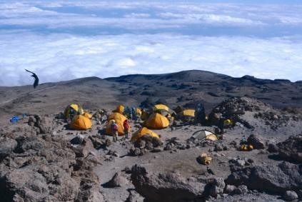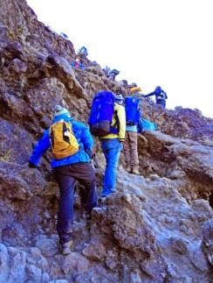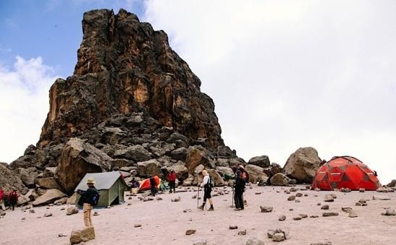

Shira Camp 2 (3,850 meters) to Lava Tower (4,600 meters) and then
Barranco Camp (3,900 meters)

Zone: Low alpine zone / High alpine zone

Day three is a challenging trek East off the Shira Plateau through the ‘Garden of the Senecios’, up to Lava Tower and the Shark’s Tooth rock formation at
4,600 meters and then back down via the Southern
Circuit to Barranco Camp (3,900 meters).

The route is approximately 11km / 7 miles in length and takes 5-7 hours to complete. Although you end the day at a very similar elevation to when you started from Shira Camp, it gives you a chance to
climb high and sleep low which is important for proper acclimatisation.

Day 4

Barranco Camp (3,900 meters) to Karanga Camp (3,960 meters)

Zone: High alpine zone

Day four on the Machame Route begins with a steep traverse up
the Barranco Wall; a 257 meter rock face that requires basic scrambling skills to the top of the Karanga Valley. The path then follows a series of inclines and declines to Karanga Camp (3,960 meters).

We spend a night at Karanga Camp before continuing onto Barafu.

Day 5

Karanga Camp (3,960 meters) to Barafu Camp (4,680 meters)

Zone: High alpine zone

When you arrive at Barafu around mid-afternoon you will be served an early dinner and encouraged to get some shut-eye as the summit trek, the final piece of our journey, commences around midnight.
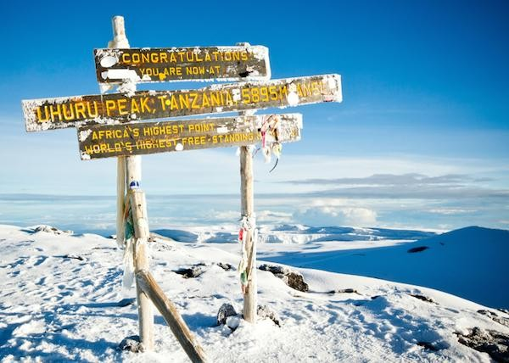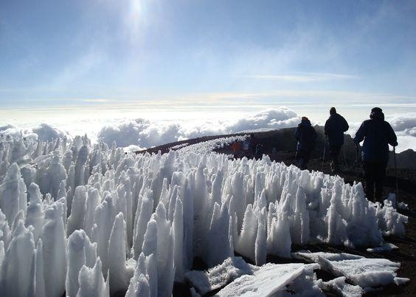
Barafu Camp (4,680 meters) to Uhuru Peak (5,895 meters) and then Mweka
Camp (3,100 meters)

Zone: Glacial zone and then all previous zones

Day six is summit night (and day)! You will be awoken around 1130PM with hot tea and biscuits. Hopefully you have managed to get a few hours’ sleep; don’t worry if you haven’t as most people struggle to sleep before summit night. The adrenaline of being so close to the very roof of Africa kicks in.

Make sure that all your kit, including warm clothes, headlamp, insulated water reserves and snacks are ready for a sharp departure at Midnight. The trek up Kibo is steep and slow. The trick is to keep your momentum moving forward, one step at a time. It takes about 6-8 hours to reach the top of the crater rim
where you will see the sign for Stella Point (5,739 meters). This is not the summit of Kilimanjaro.

You still have another 156 meters of altitude to walk around the crater rim to Uhuru Peak (5,895 meters).
We will be resting briefly at Stella Point and potentially having some hot tea or hot chocolate. At this point, Dawn is approaching. Take a moment to savour where you have got to, huddle up with your group for a pep talk and then dig deep for the energy to push for the summit.

At this point you will make the decision as to whether you wish to push on to the Uhuru peak. Over
60% of climbers stop at Stella Point but most can make it to the summit if they muster the metal strength
to push through. The descent can
be very gruelling on your joints. It is recommend you use trekking poles and potentially wear gaiters to avoid fine glacial scree getting into your boots. Mweka is situated in
the upper part of the rainforest zone. The richness of oxygen and moisture in the air will be a very welcome surprise.
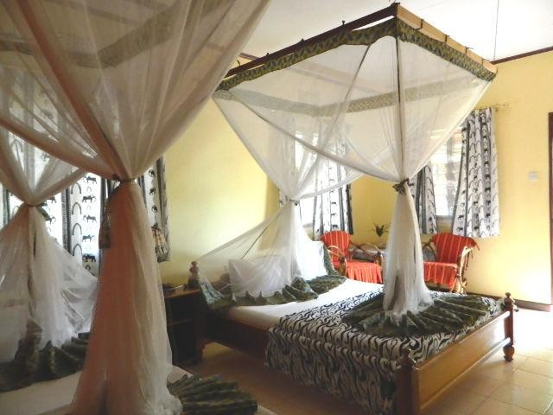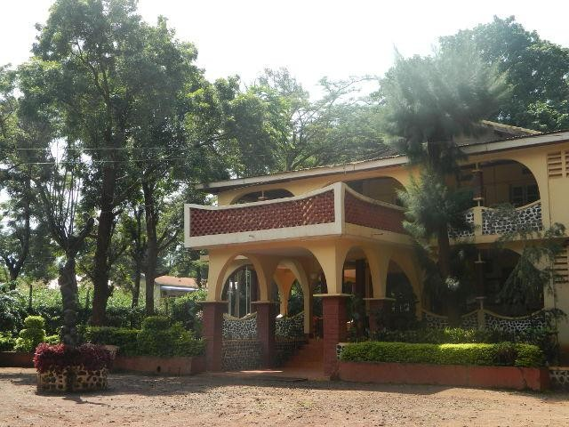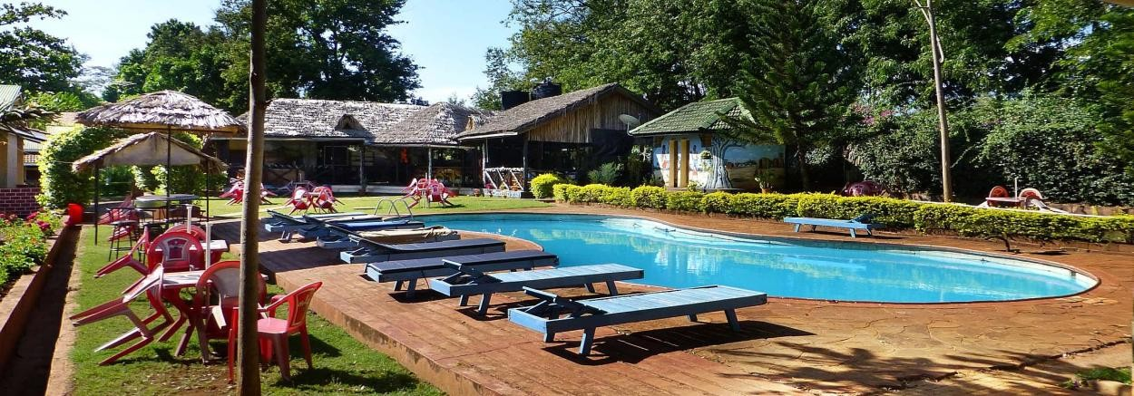

th
Mweka Camp (3,100 meters) to Mweka Gate (1,640 meters)

Zone: Rainforest

Day seven is the final day of trekking on the Machame Route. By now you will be brimming with pride and captivated by everything you just experienced. You’ll be exchanging stories and reliving the memories with your new XP Club friends.

This trek is a pleasant one through the lower rain-forested slopes and down to Mweka Gate (1,640 meters). Although you cover 9km / 5.5 miles, the trek only takes 3-4 hours. Assuming you successfully reached Stella Point or Uhuru Peak you will be presented with official certificates. It is customary to tip your trekking crew before being transported back to our hotel in Moshi.

The Mountain Inn Hotel, Moshi

As part of your XP package, you have a night’s stay on arrival and a final night’s stay on departure. Here you can take advantage of delightful services from the massage parlour to the bar/ restaurant where we will be holding our final celebration, hosted by The XP Club.

You can find out more information about the hotel here- http://www.mountaininn.co.tz
The XP Package Includes:

- 2 nights’ accommodation at Mountain Inn on half board basis [Inform us if you plan on staying longer or arriving earlier]
- Kilimanjaro National Park (KINAPA) conservation fees (entry fees)
- Kilimanjaro National Park compulsory rescue fees
- Kilimanjaro National Park hut fees
- KINAPA trained and certified English speaking guide/s
- KINAPA trained and certified porters (1 porter per person for personal mountain luggage of 15kg max.)
- KINAPA trained and certified cook / chef, utensils, cutlery, crockery etc.
- All meals and refreshments on the mountain on full board basis
- 1 x transfer from Moshi to Marangu Park Gate per group
- 1 x transfer from Marangu Park Gate to Moshi per group
- Safe and luggage storage at Mountain Inn while on trek
- Basic first aid kit per group

Kit List:

After you have finalised your booking with us, we will send you a list of items we recommend you bring with you including: clothing, baggage, sleeping kit, health related items and documentation.

Thankfully, due to our experience we can give you a realistic view of how much you need and what will be superfluous.

We will also inform you as to which medical precautions you must take prior to coming as well as advice on training.

Flights

Flights are not included in our package but can be purchased for around £400-£500 (return).

If you are coming from the UK, your best options are to fly via Amsterdam (KLM), Kenya (Kenyan Airways) or Ethiopia (Ethiopian Airlines). There are no direct flights from the UK to Kilimanjaro International Airport.

Check www.skyscanner.net for further information

Don’t Want To Come Home Straight Away?

Ask us about Tanzanian safari, hot air ballooning and the neighbouring paradise island of Zanzibar.

Check out Instagram.com/XPclub or @XPclub on Instagram for footage of our previous climb.

